|  |
| --- |
|  |
| Capstone Project Document |

**First Aid Viet Nam**

Report #2 – Screen Design

|  |  |  |
| --- | --- | --- |
| **First Aid Viet Nam** | | |
| **Group Members** | Nguyễn Phúc An |  |
| Đàm Huy Hùng |  |
| Nguyễn Tiến Dũng |  |
| Mai Trung Kiên |  |
| Nguyễn Duy Anh |  |
| **Supervisor** | Mr. Nguyễn Văn Sang | |
| **Project code** | FAVN | |

**- -**

# SIGNATURE PAGE

AUTHOR: Nguyễn Phúc An

Team member

REVIEWERS: Đàm Huy Hùng

Project manager

APPROVAL: Nguyễn Văn Sang --/--/--15

Supervisor

Record of change

*A - Added M - Modified D – Deleted

|  |  |  |  |  |  |
| --- | --- | --- | --- | --- | --- |
| Effective Date | Changed Item | A,M,D | Change Description | Reason for Change | Rev. Number |
| 28/Sep/2015 | Create Screen Design | A | First version | Create Screen Design | 1.0 |
|  |  |  |  |  |  |
|  |  |  |  |  |  |
|  |  |  |  |  |  |
|  |  |  |  |  |  |
|  |  |  |  |  |  |
|  |  |  |  |  |  |
|  |  |  |  |  |  |
|  |  |  |  |  |  |
|  |  |  |  |  |  |
|  |  |  |  |  |  |
|  |  |  |  |  |  |
|  |  |  |  |  |  |
|  |  |  |  |  |  |
|  |  |  |  |  |  |
|  |  |  |  |  |  |
|  |  |  |  |  |  |
|  |  |  |  |  |  |
|  |  |  |  |  |  |
|  |  |  |  |  |  |
|  |  |  |  |  |  |
|  |  |  |  |  |  |
|  |  |  |  |  |  |
|  |  |  |  |  |  |

Table of Contents

SIGNATURE PAGE 1

Introduction 3

1.1 Purpose 3

1.2 Definitions, Acronyms and Abbreviations 3

1.3 Overview 3

2 Screen Flow 3

2.1 First Aid Application 4

2.2 Ambulance 14

2.3 Admin/Expert 14

2.4 Dispatcher 14

# Introduction

## Purpose

Make the user can more clearly understand the flow of the screen in a product of the system. To ensure consistency and simplicity in detailed design across all displays within a product interface of the system. Definitions, acronyms, abbreviations, references and overview of each application of FAVN system.

## Definitions, Acronyms and Abbreviations

|  |  |  |
| --- | --- | --- |
| Abbreviations | Description | Comment |
| FAVN | First Aid Viet Nam |  |
| Q&A | Question and Answer |  |

1. Definitions, Acronyms and Abbreviations

## Overview

Chụp ảnh 4 cái First Aid => Ambulance=> Dispatcher=>Admin/Expert

# Screen Flow

## First Aid Application

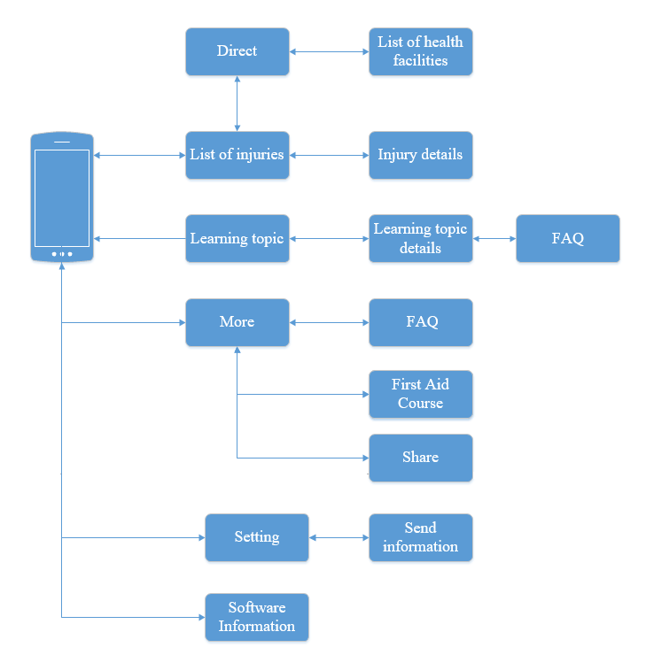

1. First Aid Screen Flow

### Emergency Screen

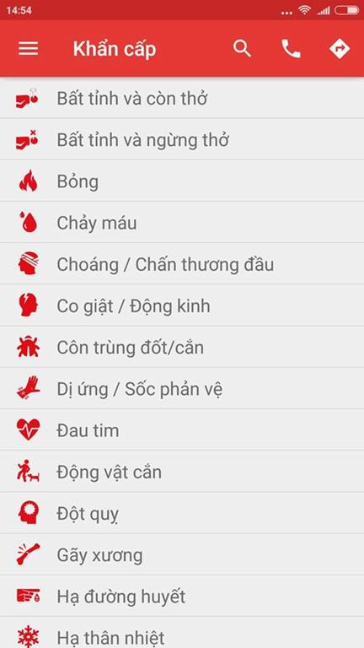

1. Emergency Screen

|  |  |  |  |  |  |  |  |  |
| --- | --- | --- | --- | --- | --- | --- | --- | --- |
| No | Field name | | Field name in Vietnamese | Type | Require | Mandatory | Max-Length | Description |
|  | Menu Bar | Menu | | Button | Tap on | Y |  | Show list of screen |
|  | Search | Tìm Kiếm | | Icon | Tap on | Y |  | Show textbox to input characters |
|  | Call | Gọi | | Icon | Tap on | Y |  | Auto dialing 115 |
|  | Direct | Chỉ đường | | Icon | Tap on | Y |  | Move to screen Direct. |
|  | List of injuries | Danh sách các trường hợp khẩn cấp | | List |  | Y |  | Show list of emergency. |

1. EmergencyScreen

#### Emergency Details

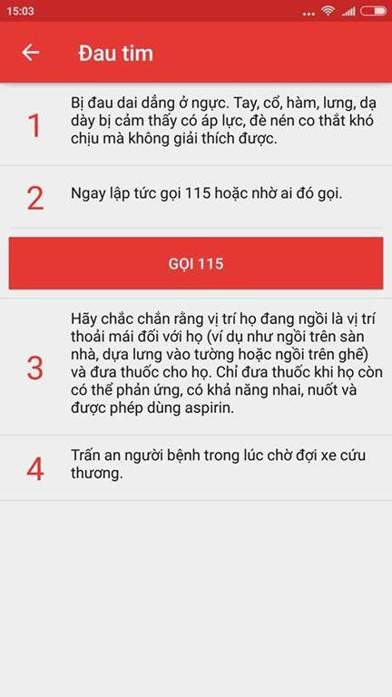

Figure 2.2.1: Emergency Details

|  |  |  |  |  |  |  |  |  |
| --- | --- | --- | --- | --- | --- | --- | --- | --- |
| No | Field name | Field name in Vietnamese | Type |  | Require | Mandatory | Max-Length | Description |
| 1 | Back button | Nút quay lại | Button |  | Tap on | Y |  | Back to screen emergency |
| 2 | Call 115 | Gọi 115 | Button |  | Tap on | Y |  | Call 115 |

**Table 2.2.1: Emergency Details**

#### Direct screen

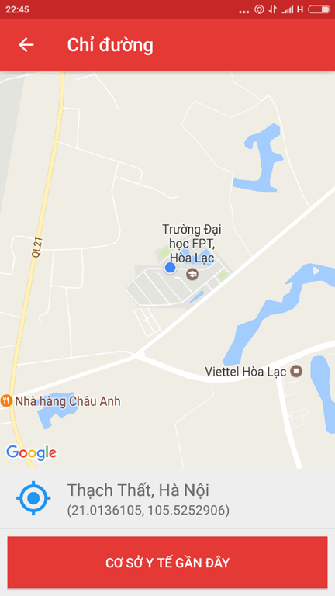

|  |  |  |  |  |  |  |  |
| --- | --- | --- | --- | --- | --- | --- | --- |
| No | Field name | Field name in Vietnamese | Type | Require | Mandatory | Max-Length | Description |
| 1 |  |  |  |  | Y |  | Display list of learning topic |
| 2 | First Aid Course | Các khóa học sơ cứu | Image | Tap on | Y |  | Show the list of First Aid Course |

#### List of health facilities

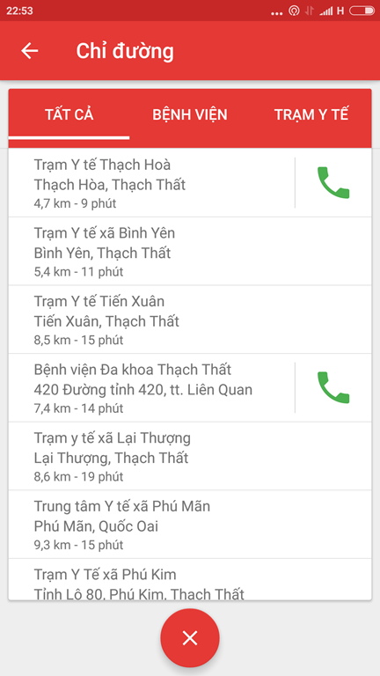

|  |  |  |  |  |  |  |  |
| --- | --- | --- | --- | --- | --- | --- | --- |
| No | Field name | Field name in Vietnamese | Type | Require | Mandatory | Max-Length | Description |
| 1 | List of health facilities | Danh sách các cơ sở y tế | List |  | Y |  | List health facilities |
| 2 | Exit | Tắt | Butotn | Tap on | Y |  | Turn off the list of health facilities |
| 3 | Hospital | Bệnh viện | Button | Tap on | Y |  | Show list of hospitals |
| 4 | Clinic | Trạm Y Tế | Button | Tap on | Y |  | Show list of clinic |

### Learning Screen

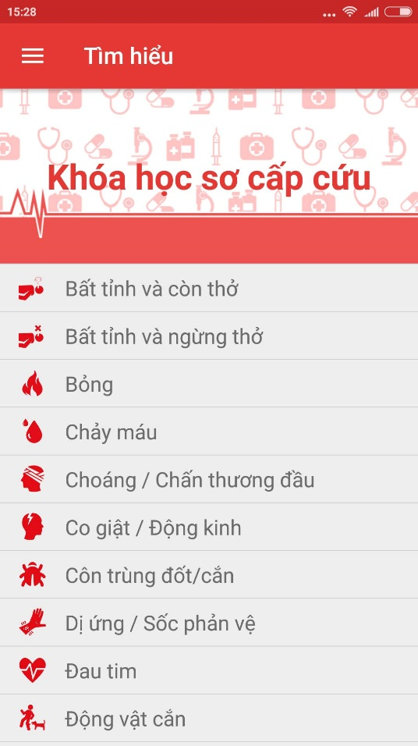

1. Learning screen

|  |  |  |  |  |  |  |  |
| --- | --- | --- | --- | --- | --- | --- | --- |
| No | Field name | Field name in Vietnamese | Type | Require | Mandatory | Max-Length | Description |
| 1 | List of learning topic | Danh sách các chủ đề tìm hiểu | List |  | Y |  | Display list of learning topic |
| 2 | First Aid Course | Các khóa học sơ cứu | Image link | Tap on | Y |  | Show the list of First Aid Course |

1. Learning screen

#### Learning topic details screen

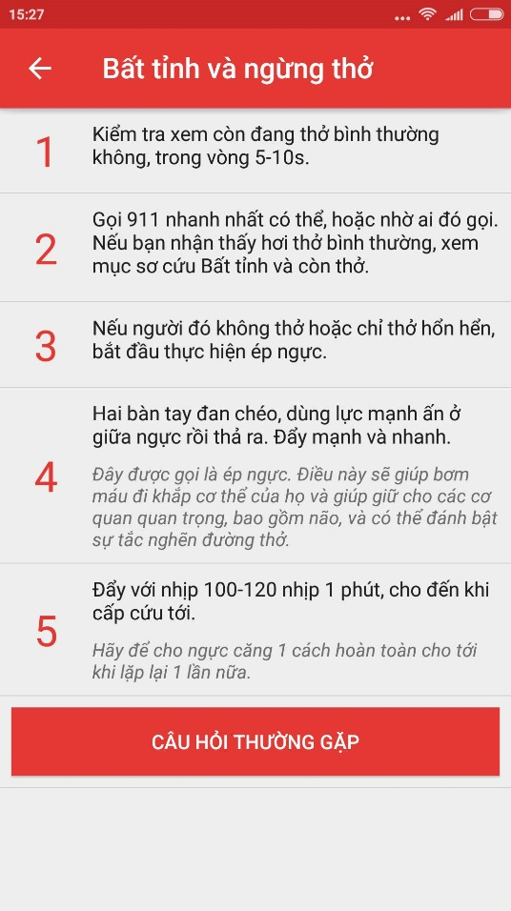

**Figure 2.3.1: Learning Topic Details**

|  |  |  |  |  |  |  |  |
| --- | --- | --- | --- | --- | --- | --- | --- |
| No | Field name | Field name in Vietnamese | Type | Require | Mandatory | Max-Length | Description |
| 1 | Back Button | Nút quay lại | Button | Tap on | Y |  | Back to Learning screen |
| 2 | Steps | Các Bước | List |  |  |  | List of steps |
| 3 | FAQ | Câu hỏi thường gặp | Button | Tap on | Y |  | List of FAQ |

**Table 2.3.1: Learning Topic Details**

#### FAQ screen

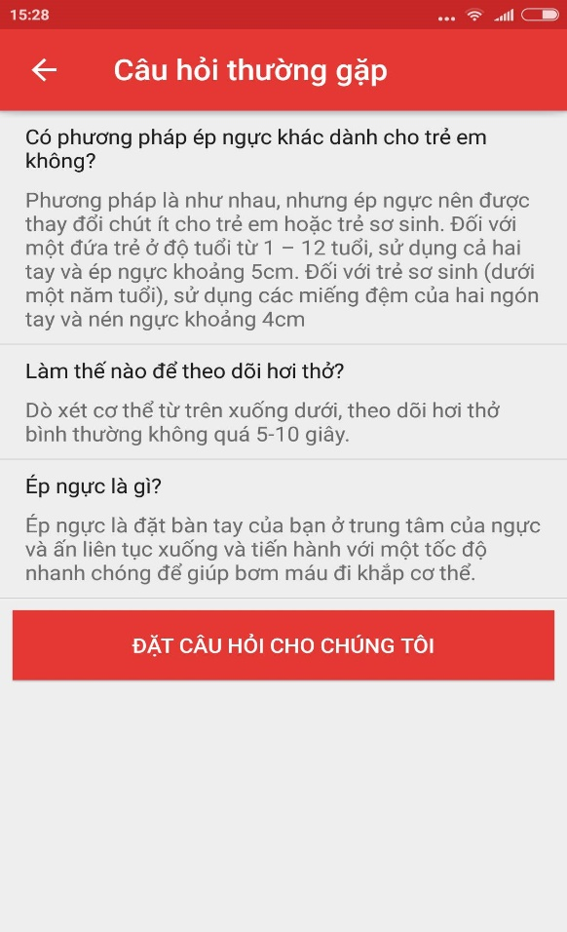

Figure 2.3.2: FAQ screen

|  |  |  |  |  |  |  |  |
| --- | --- | --- | --- | --- | --- | --- | --- |
| No | Field name | Field name in Vietnamese | Type | Require | Mandatory | Max-Length | Description |
| 1 | Back button | Nút quay lại | Button | Tap on | Y |  | Back to Learning Topic Details screen |
| 3 | List of question and answers | Danh sách các câu hỏi và câu trả lời | List |  | Y |  | Show list of FAQ |
| 4 | Button Ask a question | Đặt câu hỏi cho chúng tôi | Button | Tap on | Y |  | Move to screen to send the questions. |

Table 2.3.2: FAQ screen

#### Ý Kiến - Hỏi Đáp screen

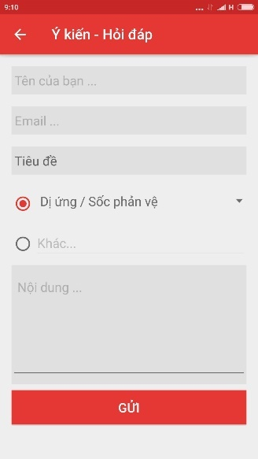

Figure 2.3.3:

|  |  |  |  |  |  |  |  |
| --- | --- | --- | --- | --- | --- | --- | --- |
| No | Field name | Field name in Vietnamese | Type | Require | Mandatory | Max-Length | Description |
| 1 | Your name | Tên của bạn | Textfield | Tap on | Y |  | Display text |
| 2 | Email | Thư điện tử | Textfield | Tap on | Y |  | Display text |
| 3 | Title | Tiêu đề | Button | Tap on | Y |  | Display tittle |
| 4 | Content | Nội dung | Textfield | Tap on | Y |  | Display text |
| 5 | Send | Gửi | Button | Tap on |  |  | Send question to system |
| 6 | Back | Quay lại | Button | Tap on | Y |  | Back to previous screen |

Ý Kiến-Hỏi Đáp screen

### More

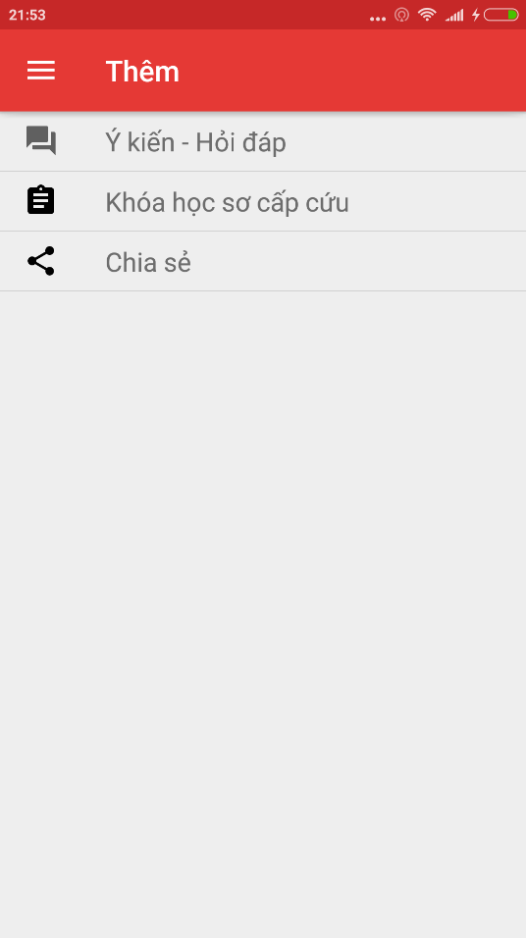

1. Other screen

|  |  |  |  |  |  |  |  |
| --- | --- | --- | --- | --- | --- | --- | --- |
| No | Field name | Field name in Vietnamese | Type | Require | Mandatory | Max-Length | Description |
| 1 | FAQ | Ý Kiến – Hỏi Đáp | Button |  | Y |  | Move to FAQ screen |
| 2 | First Aid Courses | Các khóa học sơ cứu | Button |  | Y |  | Move to list of First Aid Courses |
| 3 | Share | Chia sẻ | Label |  | Y |  | Share application on communication social network |

1. Statistic

#### FAQ screen



Figure 2.3.3:

|  |  |  |  |  |  |  |  |
| --- | --- | --- | --- | --- | --- | --- | --- |
| No | Field name | Field name in Vietnamese | Type | Require | Mandatory | Max-Length | Description |
| 1 | Your name | Tên của bạn | Textfield | Tap on | Y |  | Display text |
| 2 | Email | Thư điện tử | Textfield | Tap on | Y |  | Display text |
| 3 | Title | Tiêu đề | Button | Tap on | Y |  | Display tittle |
| 4 | Content | Nội dung | Textfield | Tap on | Y |  | Display text |
| 5 | Send | Gửi | Button | Tap on | Y |  | Send question to system |
| 6 | Back | Quay lại | Button | Tap on | Y |  | Back to previous screen |

Ý Kiến-Hỏi Đáp screen

#### First Aid Courses screen

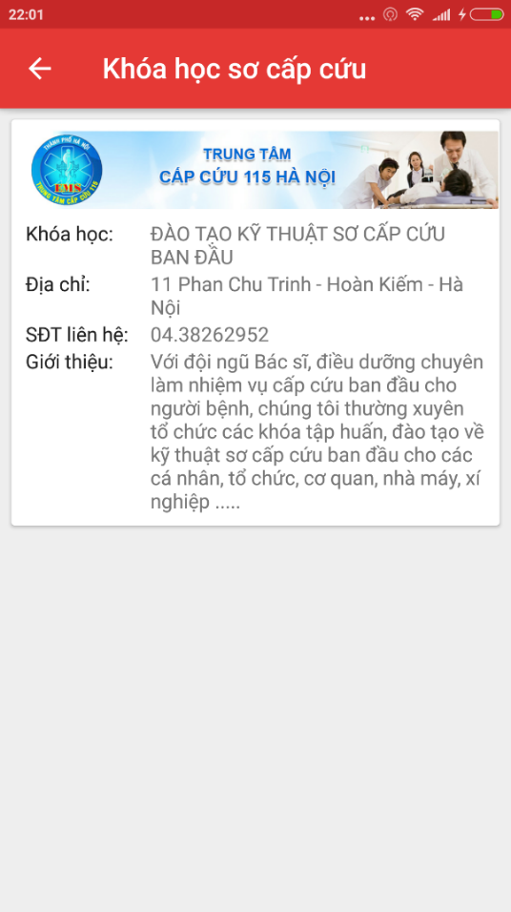

|  |  |  |  |  |  |  |  |
| --- | --- | --- | --- | --- | --- | --- | --- |
| No | Field name | Field name in Vietnamese | Type | Require | Mandatory | Max-Length | Description |
| 1 | List of First Aid Courses | Danh sách khóa học sơ cứu | Textfield | Tap on | Y |  | Display text |

### Software information

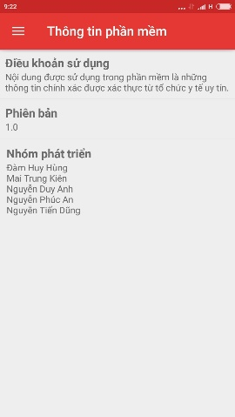

1. Software information screen

|  |  |  |  |  |  |  |  |
| --- | --- | --- | --- | --- | --- | --- | --- |
| No | Field name | Field name in Vietnamese | Type | Require | Mandatory | Max-Length | Description |
| 1 | Term of use | Điều khoản sử dụng | Text |  | Y |  | Show term of use |
| 2 | Version | Phiên bản | Text |  | Y |  | Show the version of software |
| 3 | Name of developers | Tên nhà phát triển | Text |  | Y |  | Show the name of developers. |

1. Software information screen details

## Ambulance

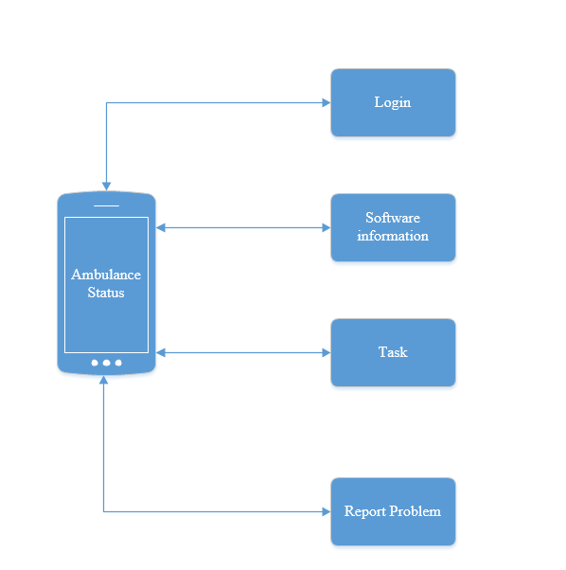

### Login

### Task

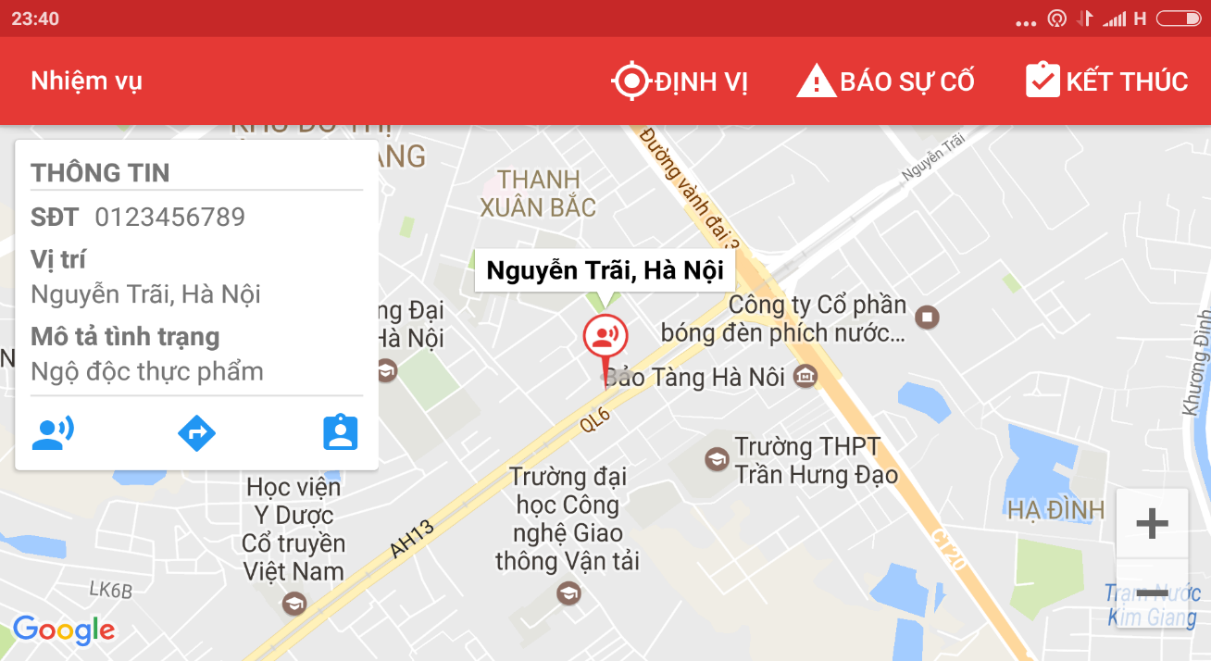

|  |  |  |  |  |  |  |  |
| --- | --- | --- | --- | --- | --- | --- | --- |
| No | Field name | Field name in Vietnamese | Type | Require | Mandatory | Max-Length | Description |
| 1 | Task | Nhiệm vụ | Label |  | Y |  | Name of screen |
| 2 | Locate | Định vị | Icon | Tap on | Y |  | Locate position of ambulance team |
| 3 | Information board | Bảng thông tin | Text |  | Y |  | Show the information of victims |
| 4 | Victim current position | Vị trí hiện tại của nạn nhân | Icon | Tap on | Y |  | Location position of victim |
| 5 | Direct | Chỉ Đường | Icon | Tap on | Y |  | Show the direct from ambulance team to the victim, include distance |
| 6 | Report problem | Báo Cáo Sự Cố | Icon | Tap on | Y |  | Call the center to report problem |
| 7 | Finish | Kết thúc | Icon | Tap on | Y |  | Report that mission completed or cancel |

## Admin/Expert

## Dispatcher

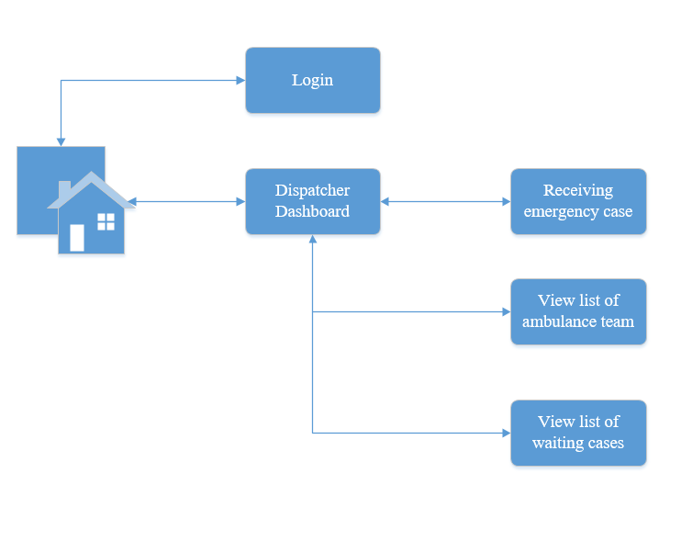

### Login



|  |  |  |  |  |  |  |  |
| --- | --- | --- | --- | --- | --- | --- | --- |
| No | Field name | Field name in Vietnamese | Type | Require | Mandatory | Max-Length | Description |
| 1 | Login | Đăng Nhập | Button | Click on | Y |  | Login to the dispatcher dashboard page |
| 2 | User name | Tên đăng nhập | Textfield | Click on | Y |  | Fill the user name |
| 3 | Password | Mật Khẩu | Textfield | Click on | Y |  | Fill the password |

### Dispatcher’s Dashboard

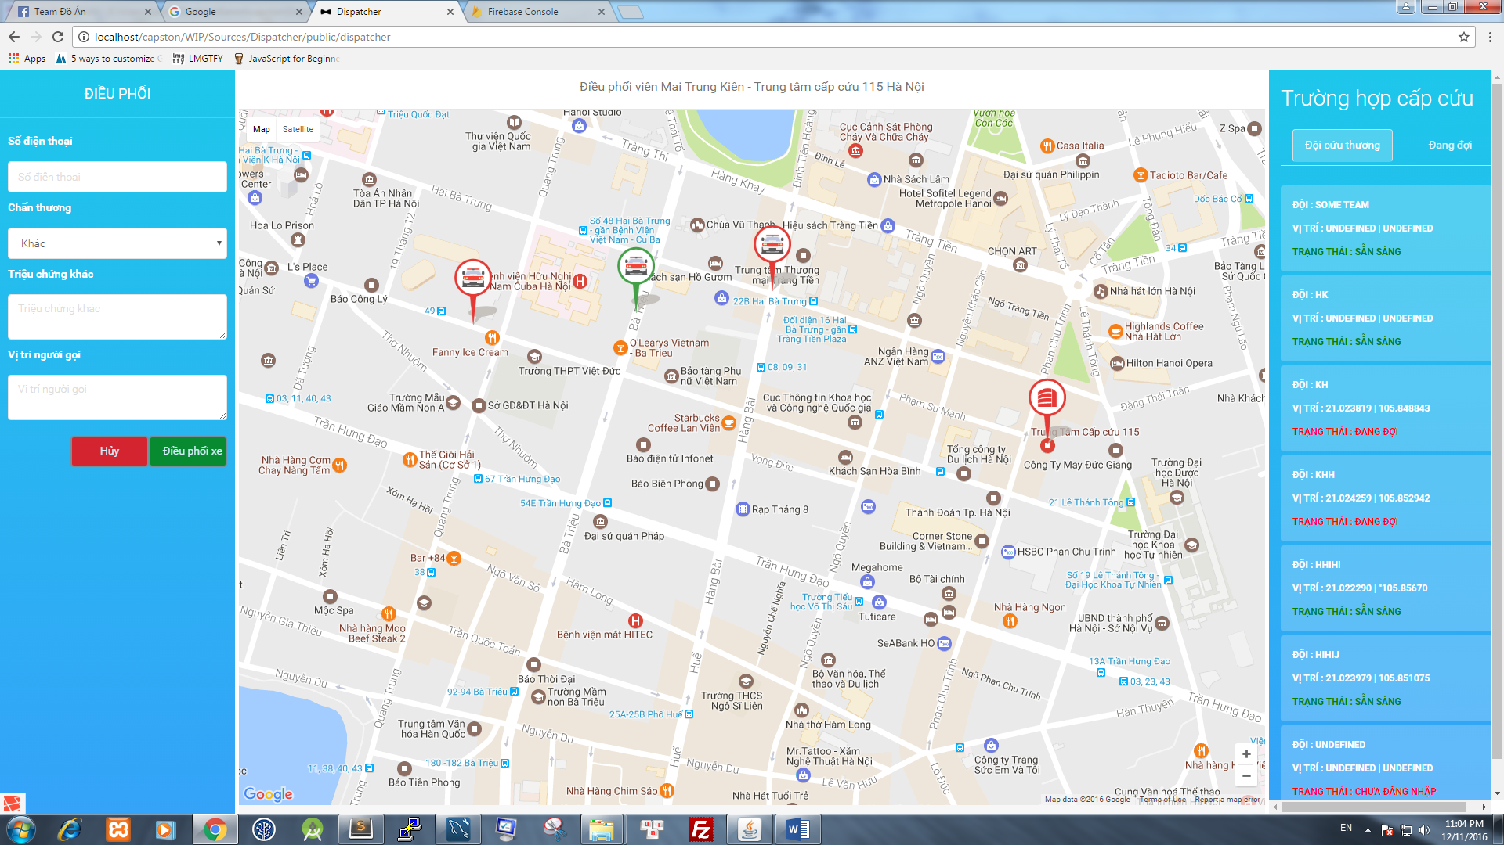

|  |  |  |  |  |  |  |  |
| --- | --- | --- | --- | --- | --- | --- | --- |
| No | Field name | Field name in Vietnamese | Type | Require | Mandatory | Max-Length | Description |
| 1 | Phone number | Số Điện Thoại | Text field | Click on | Y | 11 | Fill phone number of caller. |
| 2 | Injury | Chấn Thương | Dropdown list | Click on | Y |  | Show list of injuries |
| 3 | Caller’s Position | Vị trí người gọi | Text field | Click on | Y |  | Fill the position of caller. |
| 4 | Other injuries | Chấn Thương khác | Text field | Click on | Y |  | Fill the injury |
| 5 | Dispatch | Điều phối xe | Button | Click on | Y |  | Dispatch the ambulance for the emergency cases |
| 6 | Cancel | Hủy | Button | Click on | Y |  | Cancel the emergency case |
| 7 | Ambulance Team | Đội cứu thương | Button | Click on | Y |  | Show list of ambulance, include ambulance information |
| 8 | Waiting | Đang đợi | Button | Click on | Y |  | Show list of waiting cases |